Sci 9 Electricity Notes
I. What is Electricity? How do we Design Electrical Circuits?

Electric charges are positive and negative particles that exert an electric force.
How do you know if something is a positively charged object, negatively charged object or a neutral object?
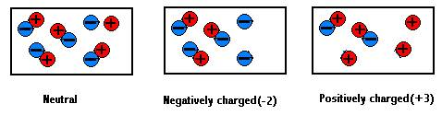
Positively charged objects have more____ than ______charges on them. Can you think of some positively charged particles? _____________ , ___________________,
Negatively charged objects have more ______than ______ charges on them. Can you think of some negatively charged particles? _______________, ___________________,
Neutral objects have an ________________number of + and – charges on them.
How can we tell if something is charged (carries an electric charge)? _______________________________________________________________________________________________
What are the 3 Laws of Electric Charges?

3 Laws of Electric Charges
1. Opposite charges ________________________________________________________________________
2. Like charges ______________________________________________________________________________
3. Charged objects _______________________________ neutral objects.

STATIC ELECTRICITY is the build up of an electric charge when 2 objects are in contact with each other (rubbed, touched, collide, blown together in high winds……..). Sometimes these charges stay put (static) but many times they move causing unbalanced charges (there is a build up of charge in an object).
What do you often see or feel when you rub your feet against an carpet and then touch a person or a doorknob? _______________________________________________________________________________________________________
This is called an ELECTRIC DISCHARGE: Ex. lightning, power surges. Electric discharges remove a build up of electric charges and neutralize the unbalanced charges. This can be a safety hazard and cause shocks, damage electronic equipment, cause fires or explosions as electrons enter or leave an object to balance the charges.
How can we neutralize unbalanced electric charges safely?
1) Grounding: connecting an object to Earth with a conducting wire. The earth is so large it can
easily absorb or supply enough electrons to neutralize unbalanced charges safely).
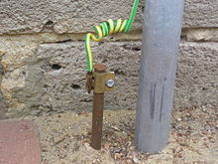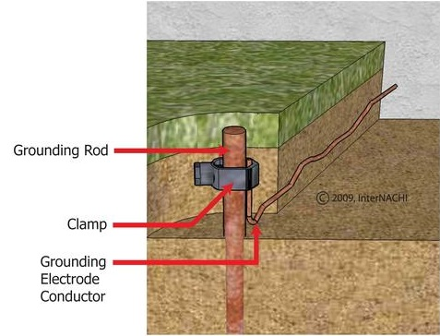
2) Ionizers: (used in industrial situations, produce + and – ions to neutralize unbalanced charges).
Positive uses of electrostatic charges! Dust removal, electrostatic stickers (decals – no sticky residue), photocopiers – paper and ink are opposite charges, electrostatic painting (paint and surface are opposite charges), negative ions for health: increased numbers of negative (-) ions are supposed to encourage positive feelings, rid indoor environments of allergens i.e. smoke in hotel rooms.
LEARNING CHECK!
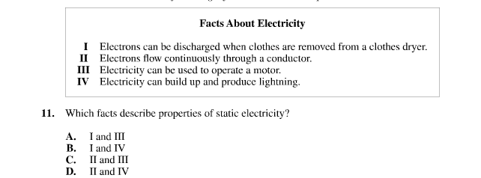

2. Why can’t we use static electricity to run motors, appliances, etc?
Conductors, Insulators, and In-Betweens
Insulators are materials that do not allow charges to move freely on or through them: ex. nonmetals because these substances hold on to their electrons tightly.
Conductors are materials that allow charges to move freely on or through them: ex. metals because these substances hold on to their electrons loosely.
Fair conductors: halfway between an insulator and a conductor ex. semiconductors
Superconductors: carry much higher charges than ordinary conductors and take up
much less space. Can be more than 7000x more efficient than conductors! Very
important for electric generators, high-voltage power lines and supercomputers.

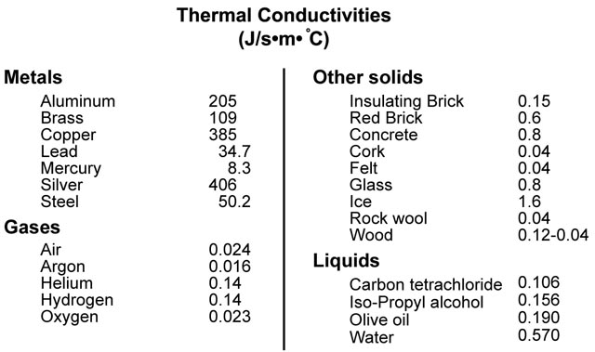

Electrical Circuits
CHECK THESE OUT!!!! Using the following link
http://terry-eng35.blogspot.ca/2012/05/electrical-circuits.html click on Electrical Circuits. Do each of the 5 “buttons”, read the info, do the activity and take the quiz at the end of each part. IN Section 1: What makes circuits work?” BUILD THE CIRCUITS ON THE ANIMATIONS WITH YOUR WIRES, SWITCHES, BATTERIES AND LIGHT BULBS TO SEE FOR YOURSELF IF THEY WORK OR NOT.

As you do Section 5 - Label the 1st 5 symbols on the 1st page of the Circuit Diagram booklet
The 2 types of Circuits: Series and Parallel

Series: Series circuits are good for simple circuits such as flashlights or when you want all of the loads to turn on and off together. (i.e. Christmas tree lights).
• Circuits that have only one current path.
• All loads are in a single row, so electrons follow a single path through each one in turn.
• If you add more loads to the circuit (i.e. bulbs), the available power is shared by all loads.
For each additional load (bulbs, motors, buzzers) there is less power available for each
individual device so bulbs will dim.
• In a series circuit, if one bulb burns out, they all go out, because each bulb is actually
part of the circuit. When a bulb goes out, the circuit is broken.
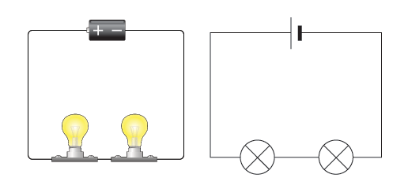

Parallel Circuits : Parallel circuits are designed to allow loads to be turned on or off independently. Most circuits in your house are parallel.
• a parallel circuit has more than one path for current flow
• any load on a separate path will be able to operate independently
• each separate pathway has its own power supply that does not have to be shared
• bulbs will not dim even if more are added because each has their own pathway to the
energy source
• if one bulb burns out, current stops going down the path that’s been broken, but there
are still other paths to go through so the other bulbs do not go out.

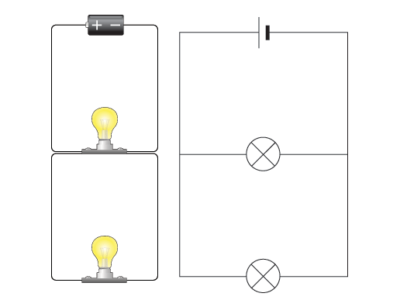
http://terry-eng35.blogspot.ca/2012/05/electrical-circuits.html watch the parallel circuit animation

Complete your circuit diagrams booklet. Label each circuit SERIES or PARALLEL.

How do we make our circuit diagrams simple and easy to read?
1) Draw with a sharp pencil on graph paper (or unlined).
2) Place components in a rectangular or square arrangement.
3) Make conductors (wires) straight lines with square corners.
4) Arrange diagrams so conductors don’t cross
5) Draw neatly, making symbols a consistent size

Learning Checks:
In the following diagram, an electric circuit is compared to water flowing out of a water tower to turn a water wheel that then does work.
Draw the electric circuit that would represent this diagram (Imagine that a pump returns the water back up to the reservoir to keep the circuit going). Label the SOURCE, LOAD, CONDUCTOR, LOAD.

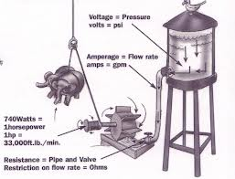

II. How is Electricity Measured?

Measuring Current (I), A and mA
Electric current (I) is the amount of charge (electrons) that passes a point in a conducting wire every second.
We measure electric current with a:
• galvanometer measures very weak currents, in milliamps, mA, 1/1000A, or a • ammeter (measures larger currents, amps, A).
To measure current we need the wires of the galvanometer or ammeter to be part of your circuit.

Measuring Electrical Energy (Voltage V)

Energy for pushing electrons is available if positive and negative charges are separated.
Batteries use energy from chemical reactions to energize and force electrons to the negative terminal (connection), leaving a positive terminal on the other side. These energized electrons can now do work such as lighting a bulb, heating a burner, charging your phones…….
We measure energy by measuring the potential difference or voltage (V) between two points in the circuit using a voltmeter. Don’t forget: voltmeter wires go OVER the circuit.
Build a series circuit with 2 light bulbs. Draw the circuit. Measure the current (I) in Amps, and the voltage (V) in 3 places. Put your measurements on your drawing.

Build a parallel circuit with 2 light bulbs. Draw the circuit. Measure the current (I) in Amps, and the voltage (V) in 3 places. Put your measurements on your drawing.

RESISTANCE
Resistance : opposes the passage of electric current and changes electric energy into heat and light. A good resistor will force the electrons to give up a great deal of energy.
The light bulb in the circuits you built is a resistor. It resisted the flow of electrons 400x more than the connecting copper wire! This build up of electrons lit the bulb and heated it up. Heating coils of toasters and blow driers are resistors too!
• a good conductor (copper wire) has a low resistance
• a poor conductor (insulator) has a high resistance
In circuits resistors are used to control current or voltage. Variable resistors can control the amount of resistance ex. dimmers, volume (surge protectors) or temperature controls (thermostats).
Fill in the following using these words: heat, electrons (2x), light, conductors, move
Current is the movement of _________________________ through _____________________ (wires), voltage makes the electrons ________________, resistors (loads) oppose the motion of the ______________________. In resistors, the energy of the moving charge (electrons) is converted to other energies like __________________ and ______________ as it passes through the load.
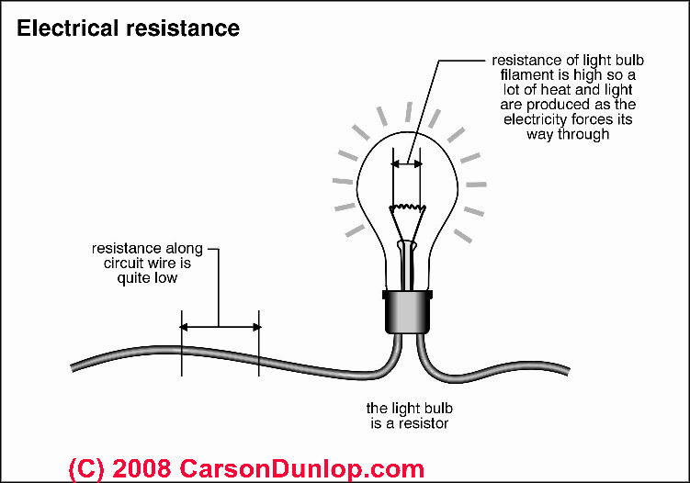
The unit for resistance is the ohm ( Ω ) and it is measured with an ohmmeter or a multimeter.
Four Factors Affect Resistance of Wires
Length | Resistance increases with length. If the length doubles, the resistance doubles.
Diameter | Resistance decreases with with diameter. If the diameter doubles, the resistance is half as great.
Temperature | As the temperature of the wire increases, the resistance of the wire increases
Material | Some metals allow electroms to move more freely than others.

Calculating Resistance and Ohm’s Law p.281-2

Resistance affects both current (I) and voltage (V). (Table 4.6 p. 281).
Ohm’s Law:
R = V resistance = voltage (potential difference) I current
Units = volts/ampere = ohms (Ω)
Ohm’s Law can be rearranged to calculate current (I) or voltage (V):
I = V V = RI R
http://www.teachersdomain.org/asset/hew06_int_ohmslaw/ simulation that shows how the 3 units in Ohm’s Law change one another.
How do we measure Electric Power?
Power = energy per unit time.
Electric power = the amount of electric energy that is converted into other forms of energy (heat, light, sound or motion) every second, or the amount of energy transferred from one place to another in a certain amount of time.

P = E Power (in watts) = Energy (in joules) 1 Watt (W) = 1 joule per second
t time (in seconds) 1 kilowatt (kW) = 1000 W

A 100 Watt light bulb converts _________ W of electric energy into l______________ and h____________ every s______________________.

For calculations: P = IV P = Power = Watts (W)
I = Current = Amps
V = Voltage = volts (V)

Draw the Power formula triangle, and write the formula to use to calculate I and V. Do the following Practice Problems (1-4 pg. 324). Then do the Power Problems Practice sheet.
1. What is the power (in watts and kilowatts) of a hair dryer that requires 10A of current
to operate on a 120 V circuit.

2. The maximum current that a 68.5 cm television can withstand is 2A. If the television is
connected to a 120V circuit, how much power is the television using?

3. A 900 W microwave oven requires 7.5 A of current to run. What is the voltage of the
circuit to which the microwave is connected?

4. A flashlight using two 1.5 V D-cells contains a bulb that can withstand up to 0.5 A of
current. What would be the maximum power of the bulb?

Efficiency
1) Light bulbs are inefficient because they also produce heat (pg. 328)
Incandescent ________ efficient
Halogen _______ efficient
Fluorescent ________ efficient
2) Calculating Efficiency

Efficiency = Useful energy output x100 Eff = E_{O} x 100
Total energy input E_{I}

Practice Problems
1) If a bulb is 15% efficient at converting electricity into light, how much energy has been
lost as heat?

2) A light bulb receives 200 J of energy but only produces 10J of light energy. What is the
efficiency of the light bulb?

3) Find the efficiency of a 23 W fluorescent tube that is used 4.0 hrs and in that time
produces 6.624 x 10⁴ J of useful light energy.

4) A 100 W incandescent bulb also produces about 6.624 x 10⁴ J over a 4.0 h period. What
is the efficiency of this bulb?

III. How Do We Design Batteries?
ELECTROCHEMICAL CELL (also called a voltaic cell) (ex. battery) : Converts chemical energy to electrical energy.
Components:
• 2 different metal electrodes in an:
• electrolyte - an ionic solution (often an acid) that conducts electrons.
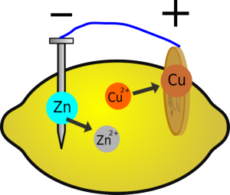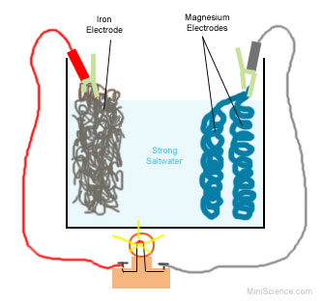
When electrodes are immersed in the electrolyte, the (-) electrode breaks down into electrons (which produce the current), and releases + ions into the electrolyte solution. The (+) electrode receives the flowing electrons through the circuit giving us electricity. Eventually the (-) electrode disintegrates and the cell dies.

The electrodes must be 2 different metals – one that generates electrons (zinc in the lemon battery), and one that is positively charged (copper in the lemon battery). This way the electrons from the negative electrode will move through the circuit because they are attracted to the (+) electrode.

IV. Energy Inputs and Outputs in Electrical Systems: MRS CHEN p. 294 - 297

ENERGY: THE ABILITY TO DO WORK. Electrical systems use a variety of energies to generate electricity.
M Mechanical (Kinetic energy, Motion)
R Radiant (light)
S Sound
C Chemical
H Heat
E Electrical
N Nuclear (Fission – splitting nuclei , Fusion – forcing nuclei together)
ELECTRICAL DEVICE | INPUT ENERGY | OUTPUT ENERGY
Incandescent light bulb: electricity passing through a high resistant wire glows brightly because of friction  Fluorescent light bulb: electricity passing through a gas excites the gas” electrons and they glow brightly.  Light-emitting diodes (LEDs): electricity passing through a semi-conductor chip makes it glow. (cheap, efficient, but small). | electricity | light
PHOTOVOLTAIC CELLS (solar power) : light strikes a semi-conductor like silicon which kicks off electrons which can be used directly or stored to power devices.
PIEZOELECTRIC EFFECT: when certain materials either generate an electrical charge in response to applied force or pressure or an electric charge causes a mechanical motion. “piezo” means press or squeeze.
Ex. quartz crystals in a watch (electricity move crystals vibrate and keeps exact time, floor tiles: peoples’ footsteps generate electricity, BBQ lighter: squeeze generates electric spark to light BBQ.

THERMOCOUPLE: a device that turns heat into electricity. It is used when heat needs to be measured accurately and to measure high heats. They are often used as regulators and safety devices: if something gets too hot it can be turned off (thermostat for your furnace, stove, water heater), an alarm will light or warning sound can go on. Thermocouples use 2 different metals (ex. copper and iron) that react differently to heat and are joined together to make a circuit. One end is the reference junction, the other end measures the heat in something like a furnace, stove, jet engine, water heater. As the measuring end heats up the electrons move in the two metals, creating a current. The potential difference (voltage) is measured and converted into a temperature reading.

http://home.howstuffworks.com/34524-gimme-shelter-replacing-a-thermocouple-video.htm
THERMOPILES (ALSO CALLED THERMOELECTRIC GENERATORS): Lots of thermocouples connected in a series. Used in remote areas to generate limited amounts of electricity. Also used to measure extremely small temperatures differences (even 1 millionth of a degree!), radiation from stars, the amount of heat in living tissues, any situation where highly sensitive reading are needed.
V. Generators, Electromagnets, Motors: the amazing interactions between magnets and electricity!

Batteries are good for small, portable electricity needs. But what about homes? Street lights? Industrial sites? We use electrical generators.
Electrical generators
• convert mechanical (moving parts) energy into electrical energy.
• generate electricity by mechanically rotating a coil of wire inside a magnet which creates an electric current in the wire. The force used to rotate the wire coil is usually supplied by steam, falling water, or wind (steam turbines, hydroelectric turbines, wind turbines). Ex. wind turbines, turbines turned by thermal, nuclear or geothermal energy in powerplants, or moving water – rivers and tides.
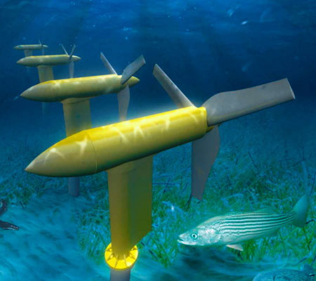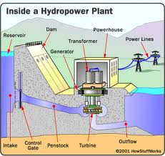

How do electrical generators work? They depend on electromagnets! A potential difference (voltage) is induced by a wire moving near a magnet. If we connect this wire to a circuit a current flows.
We can also make an iron core into a magnet by moving electricity around it. You can make a simple electromagnet sending an electric current through a wire coiled around a soft iron core like a nail. One end of the core becomes the N pole, the other the S pole.

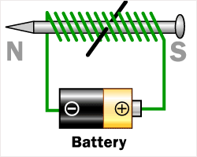
You can increase the magnetic strength by
1) increasing the # of coils, or
2) increasing the current.

Go to this phet site: http://phet.colorado.edu/en/simulation/magnets-and-electromagnets . Click on the electromagnet. What can you do to increase its magnetic strength (the G values on the Field meter increase as the magnets strength increases)?

How does a motor work? They are constructed in exactly the same way as electrical generators. However, instead of turning a coil of wire between a magnet using external forces like wind, steam, or water, to generate electricity, a motor uses electricity to make a coil of wire spin between the poles of a magnet – this rotating coil is on an axle that then turns something – a fan, your car drive shaft, etc.

• There are 2 types of generators and motors: DC (direct current) and AC (alternating current).
Advantages of AC current motors and generators: AC current can easily increase and decrease voltage as needed through transformers, and can use the high voltages needed to carry electricity long distances, but then decrease the voltage for safe usage in homes and businesses. AC generators are the most common. AC motors are found in larger appliances (dishwashers, washing machines, garage door openers, furnaces).

AC motors and generators use alternating current. AC current changes direction (alternates) - it switches every 180º (1/2turn) from (+) to (-) direction and back and travels in cycles.
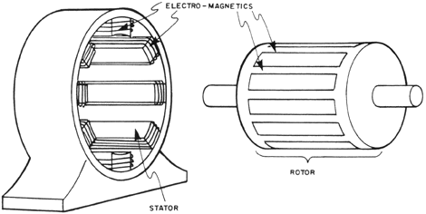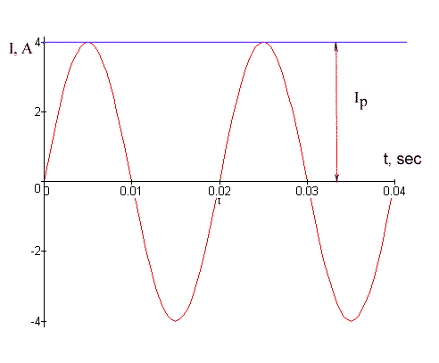

• DC generators or motors are simpler than an AC generator or motor. The current only goes in one direction and does not alternate because they use a split ring commutator.
https://www.youtube.com/watch?v=Q2mShGuG4RY
DC motors have 5 main parts:
a. armature: spinning wire coil
b. split ring commutator
c. brushes
d. field magnets
e. leads
The load is what is moved by the motor.

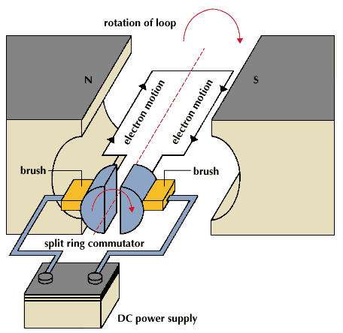

In a DC electric motor, a rotating coil of wire (the armature) is connected to a source of electrical energy through leads and brushes and becomes an electromagnet as current flows into it through a split ring commutator. The armature is attracted and repelled by the stationary field magnets, and it begins to rotate. The split ring commutator acts as a switch, cutting off and then reversing the direction of current flow so every ½ turn (180º) the armature reverses its poles, which keeps it turning. This makes a DIRECT CURRENT (the current is always in one direction).

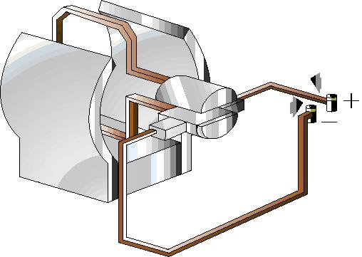
Label the armature, field magnet, brushes, and commutator on the DC generator

Label the St. Louis Motor (direct current motor) practice sheet with brushes, commutator, armature, leads, field magnets.

VI. How is Electricity Generated In Canada? Is this OK?

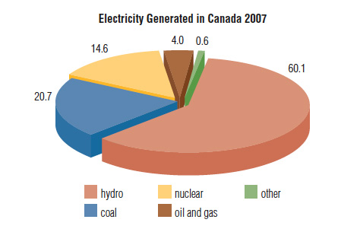
All commercial electrical energy in Canada is produced by electrical generators.
These electrical generators have HUGE magnets. Turbines spin coils of wire between the magnets. The turbines are driven by energy from water, coal, nuclear fission, oil and gas, solar, or wind energy.
Electrical energy is generated by different sources, depending on the location in Canada.
In Ontario/Quebec/BC energy is generated predominantly from hydroelectric energy. (rushing water turns the turbines)
In Alberta/Saskatchewan energy is generated predominantly energy from fossil fuels (coal, oil and gas).
Thermo-electric energy uses heat to make steam that turns the turbines. Fossil fuels, and biomass (trees, crops, animal and municipal wastes) are burned to provide. Nuclear fission and geothermal systems provide heat to make steam.

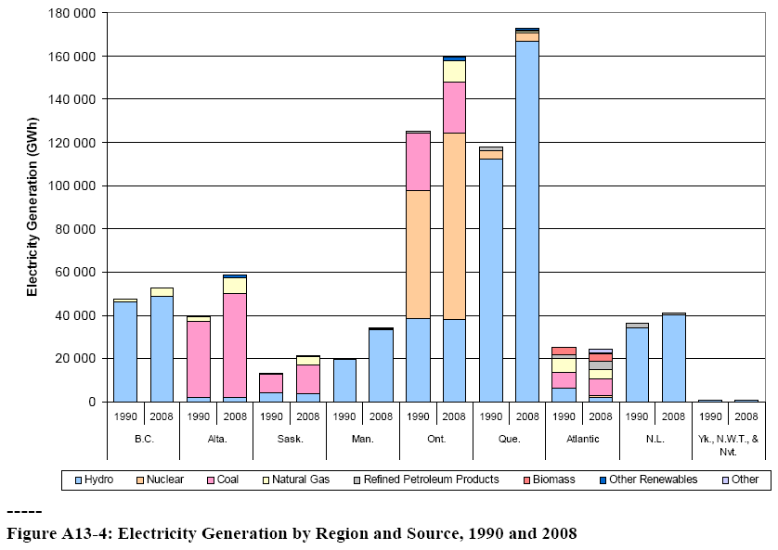

Which of the following electrical energy sources are renewable resources? Non-renewable?
Fossil fuels, biomass, wind, water, solar, nuclear, geothermal

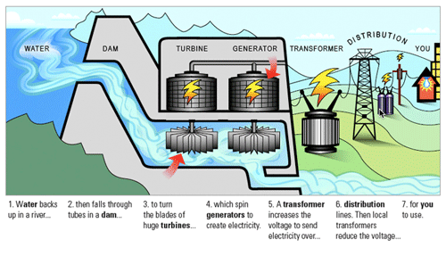
Complete the following table:
ADVANTAGES  DISADVANTAGES | FOSSIL FUELS  (COAL, OIL, GAS) | HYDROELECTRIC  (RIVERS, TIDAL) | NUCLEAR  (NUCLEAR PLANTS)
ADVANTAGES
DISADVANTAGES

Step Up and Step Down Transformers bring Generated Electricity to the Power Grid

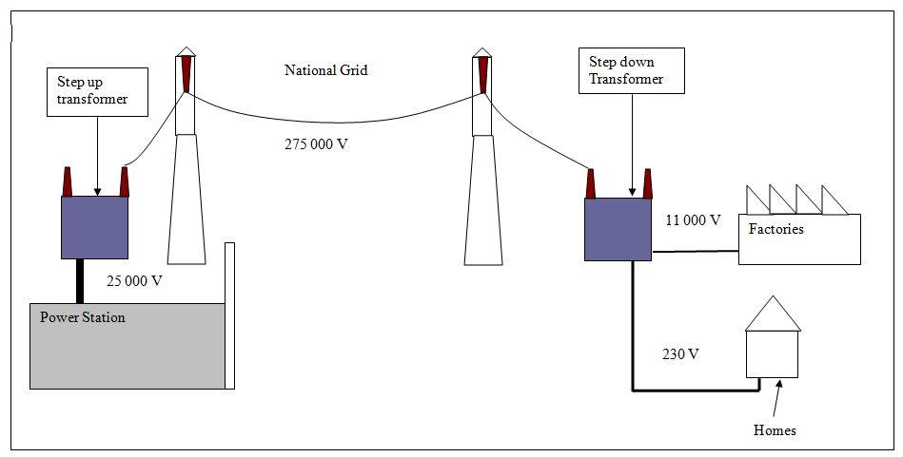
Cogeneration
Now we are designing thermoelectricity-generating stations as cogeneration systems that produce electricity but harness the excess heat generated in producing electricity to supply thermal energy to heat industrial or commercial buildings. Ex. an electricity generating plant in provides the heat needed for all of its offices, and for a huge attached industrial greenhouse.
