Topic 5 Environmental Monitoring: Water Quality
We need to monitor our air, water and soils for toxins so that they do not harm us and other living things. What are we looking for? How do we monitor the environment for toxins?
Persistent and Nonpersistent Pollutants
Nonpersistent Pollutants: wastes that can be broken down. Ex. fertilizers and sewage.
Persistent Pollutants: accumulate in the environment because they break down very slowly or not at all. Ex. pesticides, petroleum products, and heavy metal wastes.
Both persistent and nonpersistent pollutants are a concern if they become concentrated enough to harm living things. We monitor these with chemical tests.
Algal Blooms, dissolved oxygen and Water Quality
Remember that phosphorus and nitrogen help plant growth which is why they are in fertilizers. However, when phosphate and nitrate concentrations greatly increase in a water body from run-off from fertilizer and sewage, oxygen is depleted and the organisms in the water die.
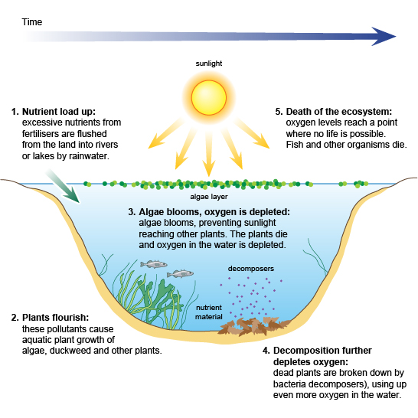
This is a serious problem causing creeping dead zones in all of our oceans. Check this out: http://www.youtube.com/watch?v=XEZpo9uLIc0&feature=related

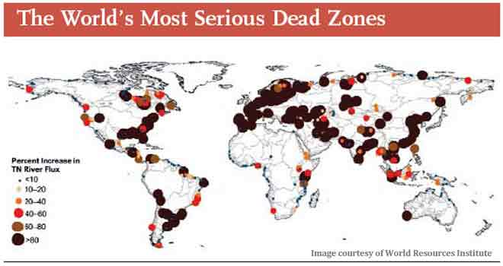

Biological Indicators can also be used to measure water quality

Polluted water bodies have decreased oxygen levels. This means many species cannot survive and the number and variety (biodiversity) of organisms decreases. Monitoring for pollution sensitive invertebrates (insects, shellfish, worms) and fish can tell us if a water body is healthy or not.

Point vs nonpoint sources of pollution
Point sources directly discharge pollutants into the air or water. These are easier to monitor and control. Ex. drainpipes and smokestacks.
Nonpoint sources discharge pollutants indirectly. These are much more difficult to control because the pollutants mix and disperse in the environment before they get to the water. Ex. feedlots, golf courses, construction sites, acid precipitation and fertilized fields.

