S90 Topic 4 Pollution Risks
A pollutant is any material, form of energy, or alteration of the environment that will cause harm to a living organism.

What are 3 materials that are pollutants?

What 3 forms of energy can be pollutants? (Think of Mrs. Chen)

What are 3 alterations of the environment that are pollutants?

Can living things be pollutants? Defend your answer.

PARTS PER MILLION (ppm)

The amount (dose) of a chemical determines its toxicity. How do we determine how much of a chemical is in our water, air, soil or food? We use parts per million (ppm). ppm tells us the #mg of toxin per 1 kg of material, or #mL per 1 000 000 mL of water.
1 ppm = 1mg/1kg or 1 ml/1 000 000 mL of water
so 10 ppm means 10mg/kg or 10 ml/1 000 000 mL of water
How do we calculate ppm?

Practice Problem 1: A nutrition label specifies that a 125 g serving of yogurt contains 7 mg of cholesterol. What is the concentration of cholesterol in a serving of yogurt in ppm?
Step 1: state your information as a ratio
7 mg cholesterol = 0.056 mg/g if your answer is not in mg/kg you need Step 2
125 g yogurt

Step 2: express the ratio in mg/kg by multiplying by a conversion factor such as 1000 g/kg or 1 mL/1g (for water).
0.056 mg/g x 1000 g/kg = 56 mg/kg = 56 ppm

Practice Problem 2: Scientists sampled a lake and found that it contained 20 ppm of a dissolved toxin. What was the concentration of this toxin by volume in the lake?
Ans: 20 mL in 1 000 000 mL of lake water.
Calculate the concentration in ppm of cholesterol and sodium in a burger using the nutrition label below:
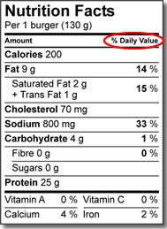
The concentration of DDT in a pond is 8 ppm by volume. This means _____ ml of DDT is in _________ ml of pond water.
Toxicity: The Danger is in the Dose
Toxicity: the ability of a chemical to cause harm to an organism.
Acute toxicity: when serious symptoms occur after only one exposure to the chemical. Ex. methyl isocyanate http://en.wikipedia.org/wiki/Bhopal_disaster
http://www.youtube.com/watch?v=Up5rbkS4CGI&feature=related

Chronic toxicity: when symptoms occur only after a chemical accumulates to a specific level after many exposures over time. Ex. lead and other heavy metals
Lethal dose 50: the dose of a chemical that will kill 50% of the population to which it is applied.
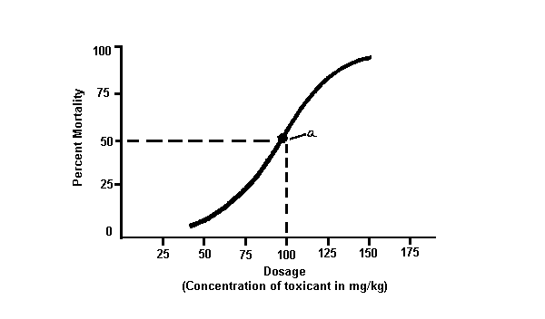

Learning Check:
1. Which of the following statements best defines the term LD₅₀?
A. LD₅₀ is the proportion of the first 50 organisms in a test population that dies when exposed
to a particular substance.
B. LD₅₀ is the proportion of the first 50 organisms in a test population that becomes sick
when exposed to a particular substance.
C. LD₅₀ is the concentration of a substance administered to a test population that kills half the
organisms in the test population.
D. LD₅₀ is the concentration of a substance administered to a test population that makes half
the organisms in the test population sick.
2.
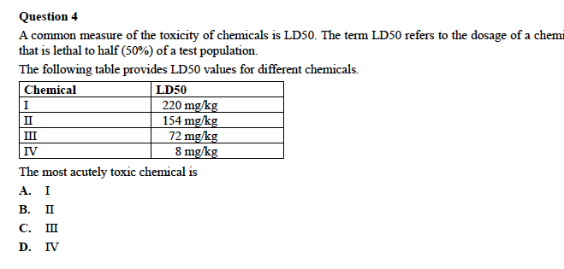
3. The lower the LD₅₀ the ____________________ (higher or lower) the toxicity.
Read “Thalidomide Issue” pg. 219. Answer the question in Fig. 3.19 on the same page.

Risk-Benefit Analysis: Read pg. 220. Summarize this page in a few sentences:

Assignment:
Topic 4 Review Questions 1-3 p. 221 Vocab
Add info to your web online Sci Focus quizzes

