S90 Topic 3 Acids and Bases
Acids and bases are important components in our everyday lives
Fill in the blanks using the following: sodium hydroxide, phosphoric acid, aluminum hydroxide, sulfuric acid.
_____________________________ is important in fertilizers, detergents and a flavoring agent in soft drinks, cheeses, jams and jellies, and foods with tangy flavor.
_____________________________ is the electrolyte in your car battery, but is also used in manufacturing paints, dyes, refining oil and gas, production of synthetic textiles.
_____________________________ is a strong base that is used in household cleaners, DRANO, solvents, and film processing.
____________________________ is a key ingredient in antacid tablets (TUMS, Rolaids).
pH Indicators
Acids and bases are solutions (dissolved in water). How do we know if a solution is an acid or a base? We use a chemical indicator, a substance that changes color when it reacts with an acid or base, or measure with a digital pH meter.
Chemical indicators include red litmus paper, blue litmus paper, universal pH paper, and cabbage juice.
Red and Blue litmus papers are blue in a base, and red in an acid.
Cabbage juice is red in an acid and green in a base.
The pH scale (pH = power of hydrogen (H⁺))
The pH scale measures the concentration of hydrogen ions in a solution. We use the pH scale to measure how acidic or basic (alkaline) a solution is. It uses the numbers 0 – 14 to describe the acidity or alkalinity of a solution.
Fill in the blanks using the following: strong acid, weak acid, neutral, weak base, strong base
pH 0 – 3 = ___________________, 4 – 6 =_________________________, 7 = _______________________,
8 – 10 = ____________________________, 11 – 14 = _________________________________
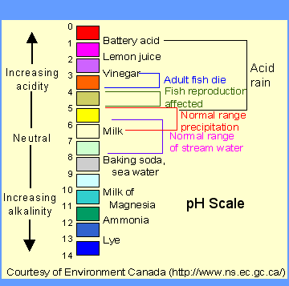
The more H⁺ ions the more acidic the solution is.

.
The more OH⁻ ions a solution has the more alkaline (basic) it is.
Fill in the following table using the following: 0 – 6.9, 7.1 – 14, red (3X), blue, green
(2X), sour, bitter, like water, slippery (like soap)
PROPERTIES | ACIDS | BASES
pH range
TASTE
TEXTURE/FEEL
CABBAGE JUICE TURNS…
RED LITMUS TURNS…..
BLUE LITMUS TURNS…..
Go to pHET site and do the following simulations :
- Acid and base solutions
- pH scale
How do we protect ourselves from acids and bases?
Neutralization Reaction: acid + base salt + water (a neutral solution pH 7)

How Do Acids Affect Our Environment? Acid Precipitation
Acid precipitation (rain, snow, fog) forms when waste gases from industrial processes and cars dissolve in water droplets in the air and form acids:
carbon dioxide + H₂O carbonic acid
nitrogen oxide + H₂O nitric acid
sulfur dioxide + H₂O sulfuric acid
Acid precipitation has a pH lower than 5.6
Acid precipitation damages aquatic life, crops, corrodes buildings and bridges, and increases leaching of nutrients from the soil. This is a huge drain on our economy.
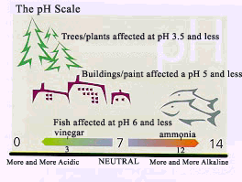
How can we control acid precipitation?
We control acid precipitation in two ways: Liming (a neutralization reaction) acid lakes, and reducing release of acids from cars and industrial plants using catalytic converters and scrubbers.
1. LIMING: treating lakes with lime (calcium carbonate) which forms a base when dissolved in water. The dissolved lime then neutralizes the acid present in the lake water by a neutralization reaction: the pH becomes neutral (pH 7) and harmless salt and water is formed. Unfortunately liming is an expensive and impractical way to deal with the many large lakes in Canada that suffer from acid precipitation.
Why does Western Canada have less problem with acid precipitation than Eastern Canada? Part of the reason is that the prevailing winds carry pollutants to the East and there is more humidity in the East to make more precipitation.
Another reason is that Western Canada has a great deal of limestone which has lots of calcium carbonate in it. Calcium carbonate in the bottom or our lakes neutralizes the acid precipitation.
2. TACKLING THE PROBLEM AT THE SOURCE by decreasing acid release into the air and water:
- CATALYTIC CONVERTERS IN VEHICLES GIVE CLEANER EMISSIONS: devices in vehicles that give cleaner emissions. They detoxify the acid rain producing carbon monoxide and nitrogen oxides in burned fuel by completely oxidizing them (adding more oxygen).
http://www.youtube.com/watch?v=DXchXMVteyk&feature=related

- SCRUBBERS: devices that uses sorbents to capture the nitrogen oxides and sulfur dioxide pollutants released by factories and power plants. The most efficient scrubbers use a COBRA device which uses aluminum oxide with copper mixed in.
http://www.youtube.com/watch?v=EGNa5pioGUg&feature=related

ASSIGNMENT:
Topic 3 Review #1-6 p. 211, #1 pg. 212.
Do Topic 3 online Science Focus Quiz and quest aplus questions

