SCI 90 TOPIC 2 A Growing Concern
How do chemicals enter our environment? How do their concentrations change?
Chemicals enter the environment by natural processes like photosynthesis, cellular respiration, and natural cycles. They also enter the environment by human activity: agriculture (pesticides and fertilizers), solid waste (garbage), waste water (sewage), combustion of fossil fuels for energy (electricity, transportation), industrial processes (natural gas, materials).
Pollution is the accumulation of unwanted waste materials in the environment that harm living things.
Pesticides
Pesticides are poisons that are designed to kill undesirable “pests” that can damage crops, and cause human diseases.
The 3 main types of pesticides are:
______________________________________________ - kills weeds
______________________________________________ - kills insects
______________________________________________ - kills fungi
DDT

DDT (dichlorodiphenyltrichloroethane) was invented by a Swiss chemist, Paul Muller. DDT was so successful in killing agricultural insect pests, as well as insects that cause human disease, Muller was awarded a Nobel Prize for his work in 1948.
DDT was very important in WWII. It completely removed the typhus threat to armies. Typhus, a disease carried by lice, totally wiped out Napoleon’s Grand Army on his retreat from Russia in the 1800s. It also wiped out fleas, malaria, bubonic plague, yellow fever, all major problems for the health of armed forces.
In the 1950s, DDT was used widely to control the threat of malaria in many countries. Each year this mosquito-transmitted disease affects over 120 million people and is responsible for 1 million deaths.
In the 1960s, scientists began to notice signs of trouble from DDT. Animals (frogs, birds, fish…) that fed on insects began to die where DDT had been sprayed. Beneficial insects (pollinators: honey bees, butterflies) also died.
Scientists found that DDT accumulated in the fat of organisms and were further alarmed because it did not break down in organism, and remained in the environment for many years and was found in the tissues of humans and organisms around the world where the insecticide had never been used.
How could DDT have spread to areas where it was not sprayed? _________________
______________________________________________________________________________________________ .

BIOLOGICAL MAGNIFICATION (BIOMAGNIFICATION) and BIOACCUMULATION

Predatory birds (like the peregrine falcon) and other organisms accumulated high amounts of DDT in their bodies. How would this happen? _________________
_____________________________________________________________________________________________ ?
http://www.youtube.com/watch?v=E5P-UoKLxlA terrestrial biomagnification
http://www.youtube.com/watch?v=MXSv0ifvDjc water biomagnification
http://www.youtube.com/watch?v=m5zVASa0u9g&feature=related Nemo
Predatory birds with high levels of DDT produced eggs with abnormal shells that cracked before the babies were ready to be born and many offspring died.
Biological magnification: when chemicals (toxins) are concentrated as they move up the food chain.
Bioaccumulation: when chemicals in the body can’t be broken down so they accumulate in tissues overtime.
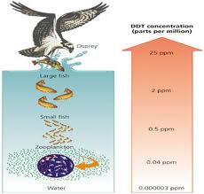

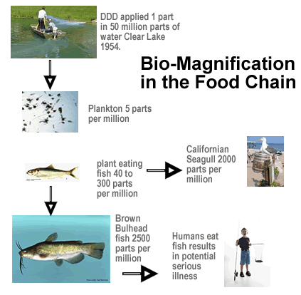
http://www.youtube.com/watch?v=20mnH6KmN1w&feature=fvwrel water pollution
This used to be a river powerpoint.
Assignment:
Investigation 3-B pg. 189 – 191. Do Analyze Questions #1-9 pg. 191
Read pg. 192. Give 2 reasons why banning DDT is a problem for malaria ridden countries.
1.
2.
What can you think of that might help solve these problems?

What is pesticide resistance? Why is this a problem?

ASSIGNMENT:
Answer question 4 and 5 pg. 196.
Do Topic 2 online Science Focus quiz

