S9 Chemistry Topic 4 and 5 Notes
Elements and the Periodic Table (Topic 4 p. 116)
Elements are the blocks on the Periodic Table. They are pure substances that cannot be decomposed (broken down) into simpler substances. Ex. carbon (C), oxygen (O), calcium (Ca) – any “block” on the periodic table.
ELEMENT SEARCH – USING YOUR PERIODIC TABLE, FIND AND NAME:

• 3 elements named after a country or other geographic place:
• 3 elements named after things in outer space:
• 3 elements named after famous people:
• 1 element important to Superman: Is its state solid, liquid or gas (circle
one)?
• 3 elements you know are metals:
3 that are metalloids:
3 that are non-metals:
• 3 elements you know are gases:
• 3 elements you know are solids:
• 2 elements you know are liquids:
Do Find Out Activity pg. 117 # 1-5 “Symbols for Elements.” You can use your Periodic
Table and/or Appendix C pg. 442 to answer the questions.
Metals, nonmetals and metalloids

The Periodic Table of Elements is an amazingly powerful scientific tool. It helps us classify elements in a variety of ways

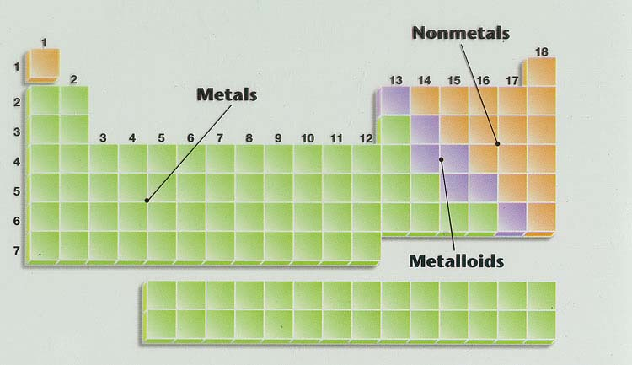
Color code the Metals, Non-Metals and the Metalloids on your Periodic Table. Pg. 440 will help you. How will you remember what your colors mean?
The 4 properties we use to compare metals, nonmetals and metalloids are:
• State at room temperature • Appearance • Conductivity • Malleability and Ductility
Using what you know or can find out about the elements that are metals, non-metals and
metalloids, complete the following table:
PROPERTIES OF METALS, NON-METALS AND METALLOIDS
 | State at room temperature  (solid, liquid, or gas) | Appearance | Conductivity of heat and electricity (good or poor) | Malleability (or brittle) Ductility (Yes/No)
Metals
3 examples:
Non-Metals
3 examples:
Metalloids
3 examples:
If you get stuck, check pg. 118.
Groups (families) and Periods
Groups (families) = columns on the Periodic
Table
Periods = rows on the Periodic Table. Elements
are arranged in periods by increasing atomic
number.
LEARNING CHECK!
• Which element is in Group 1, Period 4:
• Aluminum is in Group _____. Period _____.
• The periodic table has _____ groups and ______
periods.

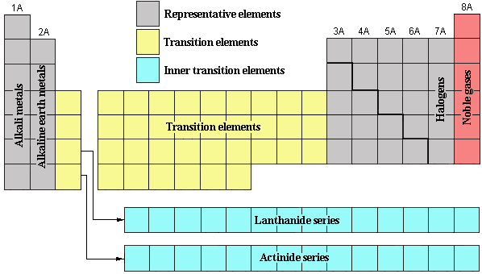

Find and label the following 4 important Groups (Families) on your Periodic Table.
Group 1 = Alkali metals. These are extremely reactive because they have one valence electron. They need to lose one valence electron to become stable like the nearest noble gas.
Group 2 = Alkaline Earth Metals. They too are reactive, but not as much as the alkali metals. They need to lose their 2 valence electrons to become stable like the nearest noble gas.
Group 17 = Halogens. They react vigorously because they need to gain 1 electron to become more stable like the nearest noble gas.
Group 18 = Noble (inert) gases. These compounds have 8 valence electrons. This is called the stable octet. They do not react because they are already stable.
Assignment: 1st pg. of Practice Booklet: “Groups of Elements” and “Element Symbols”
Elements are Atoms (Topic 5 p. 126)
Read and highlight your Atomic Theory Notes.
We now know that atoms are made of 3 subatomic particles:
• protons (positively charged, weight 1 unit)
• neutrons (no charge, weight 1 unit)
• electrons (negatively charged, weight is negligible).
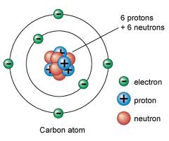
Protons and neutrons are in the nucleus. The electrons spin around outside the nucleus in different energy levels in an electron cloud. Atoms are mostly empty space.
Each element has its own square on the periodic table. Printed on this square is a great deal of information about the element
• name of the element
• atomic number = number of protons in an element.
The atomic number also = the # of electrons in an
element. (We know this because atomic elements
have no charge)
• element symbol
• atomic mass (number of protons + neutrons in an
element).
• State of the element at room temperature: the balloon
tells us that helium is a gas at room temperature

io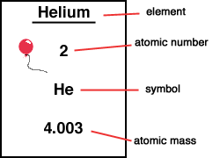
LEARNING CHECK:
You can calculate the number of protons and neutrons in an atom
atomic mass = # of protons (atomic #) + # of neutrons
atomic mass = p + n
How many neutrons does carbon have? Show your work.

What is the name of the element with atomic number 9? _____________________
How many protons does it have? ____
How many electrons? How many neutrons _____? (show your work).

Assignment: Practice sheet: “Elements and the Periodic Table”

