S90 U2 Topic 7 Notes: Chemical Reactions

• Chemical Reaction: 2 or more substances’ atoms are rearranged and become new substances.
• In a chemical reaction the properties of the new substances are different from the original substances.

• You might see the following signs that a chemical change has occurred: change in COLOR, ODOR, TEMPERATURE, GAS (BUBBLES), PRECIPITATE OR LIGHT IS PRODUCED. (Don’t forget that a change in state is NOT a chemical reaction)

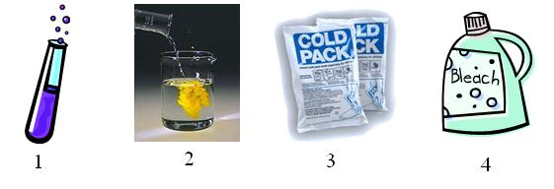
Learning Check!
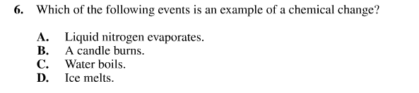
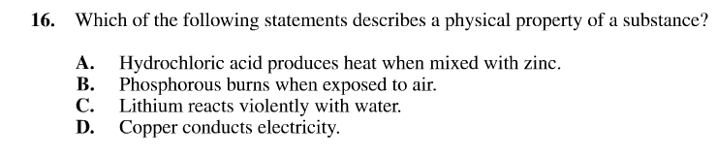
Use the following information to answer question 11 (on next page)
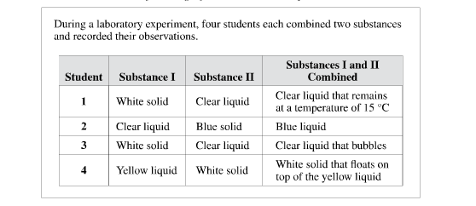
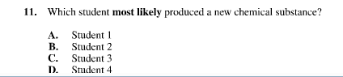
How Do We Write Chemical Equations?
• 2 ways: word equations and chemical formulas
a. silver + bromine silver bromide Ag_{(s)} + Br_{(g)} AgBr_{(s)}
b. magnesium + oxygen magnesium oxide 2 Mg_{(s)} + O_{2(g)} 2 MgO_{(s)} +light
c. acetic acid (vinegar) + baking soda (sodium bicarbonate) sodium acetate + water + carbon dioxide
HC₂H₃O_{2(aq)} + NaHCO_{3(s)} NaC₂H₃O_{2(aq)} + H₂O_{(l)} + CO_{2(g)}

• Reactants: the substances that REACT and undergo the chemical change. They are ALWAYS on the LEFT SIDE of the chemical equation.

• Products: the substances that are produced in a chemical reactions . They are ALWAYS on the RIGHT SIDE of the chemical equation.

Count the number of each atom on the reactant side in the reactions above. Count the number of each atom on the product side. What did you find?
a. Reactants: Ag ______ Br____ Products: Ag ________ Br_________
b. Reactants: Mg ______ O _______ Products: Mg ________ O _________
c. R: H ________ C ________ O _________ Na __________ P: H ________ C ________ O _________ Na __________

• Remember THE LAW OF CONSERVATION OF MASS: In a chemical reaction the total mass of the reactants is always equal to the total mass of the products. We see this when we see that the same number of each atom is on each side of the chemical equation even though the atoms are rearranged.

Learning Check!
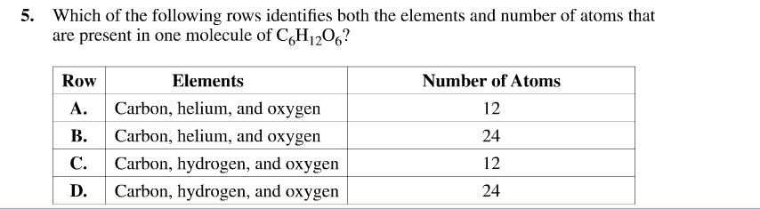

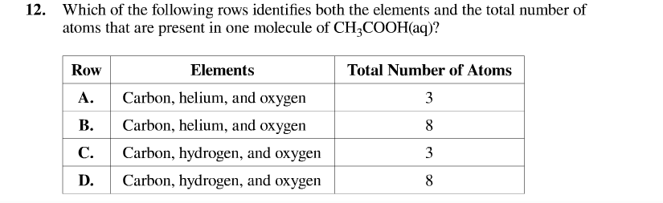
6.
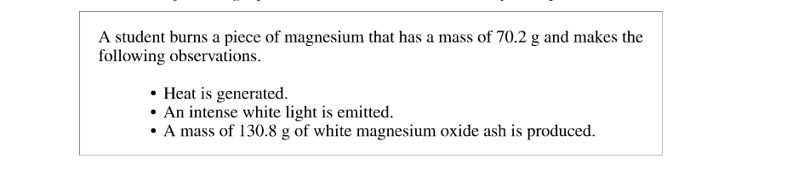
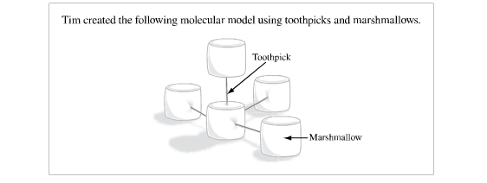

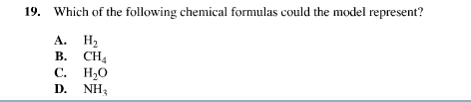

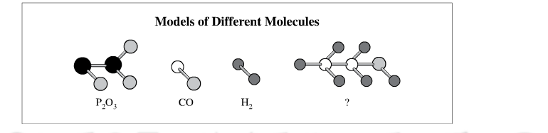
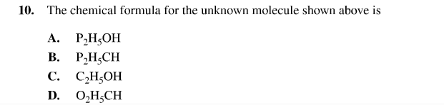

CHEMICAL BONDS

• Chemical bonds need to be broken and new ones formed in chemical reactions. Since energy is stored in chemical bonds, all chemical reactions involve changes in energy.

• Exothermic reactions release energy (heat, light) Ex. combustion, explosions CH_{4(g)} (fuel) + 2O_{2(g)} CO_{2(g)} + 2H₂O_{(g)} + heat and light energy

• Endothermic reactions absorb energy (heat, sunlight) from the surroundings Ex. electrolysis of water, cold packs 2H₂O + electrical energy 2H_{2(g)} + O_{2(g)}

Classify the following reactions as EXOTHERMIC or ENDOTHERMIC:
1. Frying an egg ___________
2. Photosynthesis ____________ CO_{2(g)} + H₂O_{(l)} C₆H₁₂O_{6(s)} + O_{2(g)} carbon dioxide + water + energy from the sun glucose + oxygen
3. Cellular respiration _________________ C₆H₁₂O_{6(s)} + O_{2(g)} CO_{2(g)} + H₂O_{(l)} glucose + oxygen carbon dioxide + water
4. A match burning ___________________
5. A firefly during mating season ___________________
6. Hot packs for hiking, skiing, hunting ________________
7. Cold packs for treating injuries, keeping food cold ________________
Assignment: Practice Sheet” Chemical Reactions: Word Equations”

