S9 Developing Atomic Theories (p. 111 - 113)
1. Ancient Greeks  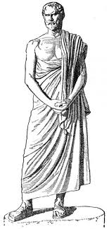 | Matter is composed of small particles that cannot be broken down = called these particles atoms from the word “atomos” (meaning indivisible).
2. John Dalton  (1808)  SOLID SPHERE, BILLIARD BALL MODEL | • Atom is smallest particle of matter , indestructible,  indivisible  • atoms are identical for one element, and different from  other elements  • atoms of different elements have different mass  • atoms of different elements combine to make compounds (CO₂)  LEARNING CHECK!  • how many different elements are in CO₂ (carbon dioxide)? ______  • How many total atoms are in CO₂ ? ________  • Build a CO₂ molecule using a chem model set
3. J. J. Thomson  (1894)  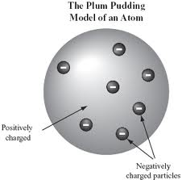  PLUM PUDDING MODEL | • the atom is NOT the smallest particle!  • every atom has tiny negative particles he called electrons  embedded in a (+) charged material.  The experiment:  • sent a high voltage through a gas discharge tube (GDT = a  sealed tube of gas under low pressure), and a glowing line  appears – (neon signs are a modern version of this) - glowing  line veered towards (+) plate  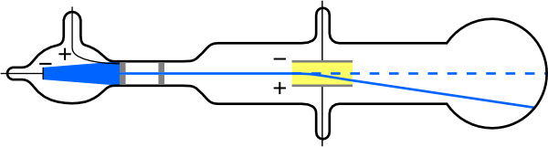  • the glowing line is a stream of negatively charged particles from  the energized gas atoms - he called them electrons  • since samples of matter normally have no charge, there must  also be negative and positive charges in the atom! He devised the  “plum pudding” model – an atom is made of electrons (negative  charges) embedded in a positively charged sphere.
3. Ernest Rutherford  (1909)  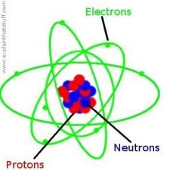  nuclear or solar system model | • An atom is mostly empty space with tiny electrons (- charge)  orbiting around a dense nucleus.  • The nucleus is made of protons (+ charge) and neutrons (no  charge) and has most of an atom’s mass..  • The experiment:  Bombarded a thin gold foil with alpha particles (large  (+) charged particles emitted from radioactive elements) from a  radioactive source. Most passed straight through the foil (so hit  nothing) – so an atom must have lots of empty space.  But some of the particles deflected at large angles and even backwards, so he concluded that the (+) charge of the atom must be in a very small, dense volume.  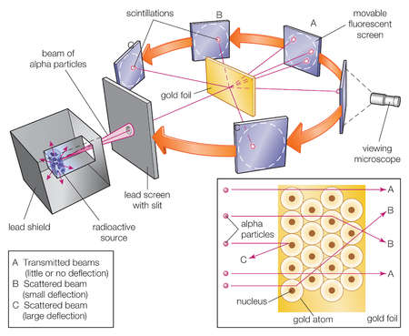  http://www.mhhe.com/physsci/chemistry/essentialchemistry/flash/ruther14.swf
Neils Bohr  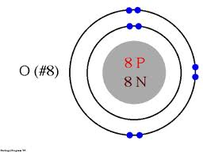  Bohr Model | Because Rutherford’s model did not explain why each element emitted  different colors (color = wavelengths of different energy), Bohr did experiments and showed that electrons can only exist in specific energy levels which emitted specific wavelengths of energy resulting in the color patterns seen in the spectroscope. If electrons absorb energy they move into a shell further away from the nucleus. If electrons release energy they move into a shell closer to the nucleus.
Louis de Broglie/Erwin Schrodinger  Electron cloud  model | Electrons exist in definite energy levels (orbitals). Exact location of electrons is uncertain so is described in terms of the probability of being found in a certain region around the nucleus.  