Sci 9 Topic 6,7 &8 Artificial Selection, Darwin’s Theory of Natural Selection, Human Impacts on Biodiversity and the “6th Extinction,” Preserving Biodiversity
Artificial selection (selective breeding) in plants and animals
Humans have used artificial selection (selective breeding) for thousands of years to domesticate animals and to develop plant species for higher yields, resistance to pests, weather conditions etc. Artificial selection (selective breeding) means breeding individual plants or animals with desirable traits together to develop varieties that have specific traits we want. The first potatoes were only the size of a quarter! The potato plants that gave the largest potatoes were selectively bred for generations to give us the large potatoes we have now. Humans also used selective breeding to domesticate animals.
Why did humans domesticate animals? Give an example.
Look at the diagram on p. 59 that traces the route of artificial selection that humans used for hundreds of years to give us so many types of dogs. Using the chart find the direct ancestor of
Chow: | Labrador Retriever:
Collie: | English Setter:
Foxhound:
Find your dog or your favorite species of dog. Trace back and find it’s direct ancestor _________________________________.

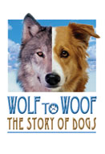

Read pg. 60. List all the traits you find that humans have selected for in plants:

Charles Darwin and the Theory of Natural Selection

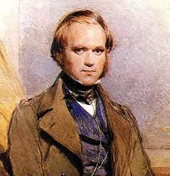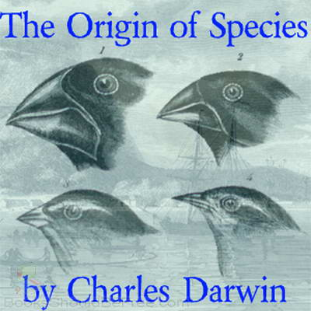
Read pg. 62 – 63. Who was Charles Darwin and what did he do?

List the 4 points of Darwin’s Theory of Natural Selection.
1.
2.
3.
4.

Read “Diversity in the Galapagos” p. 63. Using the data table, answer questions 2 and 3.
Read “Did You Know” pg. 65. Create a timeline showing and explaining what happened to the peppered moth from mid-nineteenth England to after 1970.
Answer #2, 3, 5 p. 65.
Human Impacts on Biodiversity and the “6th Extinction p. 66

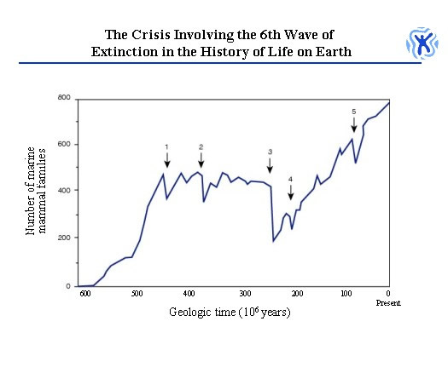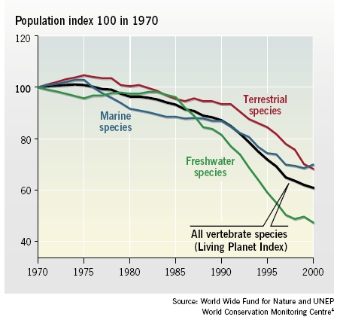
There have been 5 major declines in the Earth’s biodiversity (extinctions) in the past. Are we headed for another one? On average the earth lost 1 species to extinction per year. Now we lose 70 species to extinction each day!
Which animal group has the greatest biodiversity?
Take a look at Figure 1.59 p. 66. Which group has the most species?
Which groups have the least biodiversity?
Human Impact on Biodiversity: Loss of Habitat
Species go extinct because humans destroy their habitats. Loss of habit is the major cause of extinction and the loss of biodiversity on Earth.
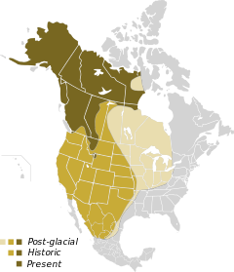
Read “Where Have the Grizzlies Gone” p. 68 and “Disappearing Habitats” pg. 69.
What does extirpation mean?
What is a bioindicator species?

Why is the grizzly bear considered a bioindicator species?

Describe the extirpation of grizzly bears in N. America. What was their original range?
What is their range now?
Where are they extirpated?
Read “Analyze” in “Where Have the Grizzlies Gone” p. 68. Why do you think the range of the
grizzly bear has decreased so much?
What is the #1 cause of loss of biodiversity?
How have humans impacted Rain Forest Ecosystems?
Look at the Table in the Find Out Activity p. 70 “How High Can It Go?” WOW! The human population is exploding! This means we need more land cleared for food (ranch animals and crops), more wood for fuel in developing nations, and we create more pollution.
Read the rest of pg. 70. Remember that most of the species in tropical rainforests are specialists: this means they have a (narrow or broad niche: choose one), so when the rainforests are cleared to make way for more humans – what happens to these species?
Can they adapt to new resources easily? Explain.

This has led to lots of extinctions in the tropics.
Assignment: Questions 1, 3, 4 p. 72.
People are working hard to slow down the loss of biodiversity that we are causing p. 73
Read p. 73 – 76 and answer the following questions:
1) How do zoos preserve the biodiversity of animals?

2) How do seed banks preserve the biodiversity of plants?

3) How does research preserve the biodiversity of organisms? Ex. The Eastern Slopes Grizzly
Bear Project in Canada p. 76.

4) How do global treaties protect endangered species? Ex. CITES – Convention on International
Trade of Endangered Species.

5) How do groups like CWF (Canadian Wildlife Federation) and CNF (Canadian Nature
Federation) help protect the biodiversity of plants and animals?

6) How do protected areas (preserves, refuges, national parks, wilderness areas) protect
biodiversity?

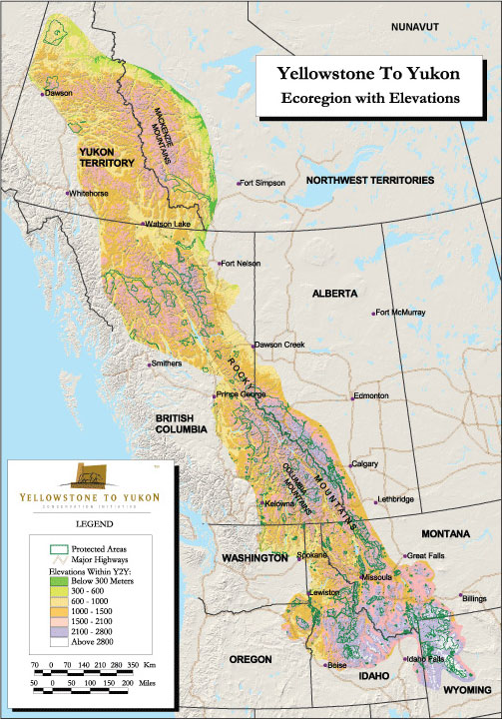
Assignment: Topic 8 Review p. 78 #2-4

