Sci9 Biodiversity Unit Topic 2 – Habitat and Lifestyle p. 16 – 25
NICHE p. 16
Niche – the habitat (where it lives) plus the jobs (what it does for its environment) of an organism.
Read p. 16 and answer the following questions:
What is the niche of the poplar trees that line the street in front of the school?
Habitat:
Jobs:

You choose an organism: _______________________. Describe its niche:
Habitat:
Jobs:

You choose an organism: _______________________. Describe its niche:
Habitat:
Jobs:

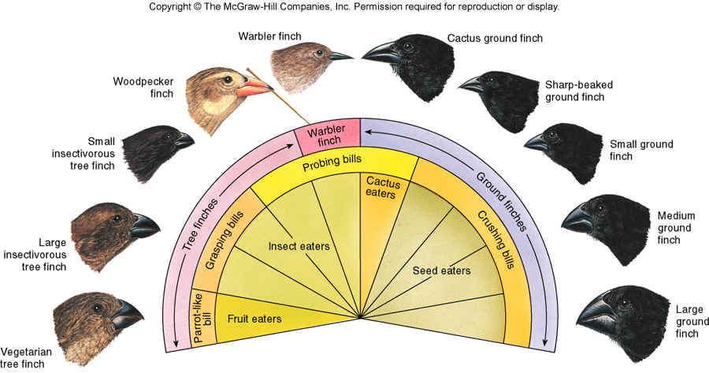

COMPETITION p. 17-18
Competition: When any resources (food, light, water, mates, energy....) organisms need are in short supply they cannot share them, they must “fight” for them to survive. There is competition between and within species. To win means to survive to breed and pass their genes to the next generation.
Read pg. 17 and answer the following questions:
Which organisms win when there is a competition?

What happens to organisms that lose?

How can organisms avoid competition?

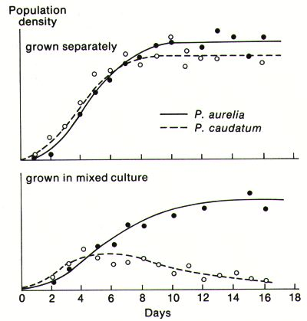
Read pg. 18. These warblers all live in the same tree. Do they share the same niche? Do they compete? Explain:

Explain “microorganism ecosystems” that inhabit humans. These are of great importance and may become a new way to treat known diseases that are difficult to treat.

http://www.pbs.org/wgbh/evolution/darwin/origin/index.html Check out how a species evolves into many different directions when it’s niche changes with a major storm. Choose one of the 4 areas on the map and see how the pollenpeepers evolve over 5 million years.
GENERALISTS AND SPECIALISTS p. 19 – 20
Generalists have a broad niche. These organisms can live in a variety of seasons, temperatures, eat a variety of foods and thus spread over large areas. Generalists tend to live in more difficult climates (i.e. northern Canada, temperate zones), because these climates have more daily and seasonal changes that species must be able to tolerate. In these regions we will not find as many species, but the species that are there can occur in large numbers.
Read pg. 19 – 20 and answer the following questions:
Are these areas of low or high species diversity?
Why can places like the Canadian ecosystem support high populations?
List some generalist species (hint: think of northern Canada).
What could be a danger in being a generalist?
Specialists have a narrow niche. These organisms live in areas where temperatures and food supplies are quite stable daily and seasonally, i.e. areas around the equator. In these areas you may see hundreds or thousands of different species, but each population is quite small.
Are these areas of low or high species diversity?

Why do places like tropical rainforests support only small populations even though they support hundreds of species?
List some specialist species.
What are the dangers of a narrow niche? Hint: read about the lion-tailed macaque of India, pg. 20 (last paragraph).
SYMBIOTIC RELATIONSHIPS
Symbiotic Relationships: when 2 organisms live in direct contact for a long period of time.
Ex. bacteria in your gut, bacteria in elk or cow stomachs, algae and fungi in lichen…….can you think of any others? (check out pg. 22).
Symbiosis can be helpful like in the clover and soil bacteria situation. This is called mutualism. Symbiosis is not always helpful , ex. parasitism.
Read “Life in the Extreme” p. 23. Why are scientists who are looking for life on other planets studying these extreme organisms?

Assignment:
http://www.pbs.org/wgbh/evolution/survival/coral/index.html check out survival in a coral reef. Explore the 3 relationships: predation and parasitism, competition, and commensalism and mutualism in all 4 reef zones, and click on “learn more” to learn about each relationship.

Do vocab and online quiz for Topic 2.
Do question 1 “Reviewing Key Terms” pg. 25.

