Sci9 Biological Diversity Topic 1: Biological Diversity and Survival p. 6 - 15
Biological diversity and species
Biological diversity: The number and variety of species in an area.
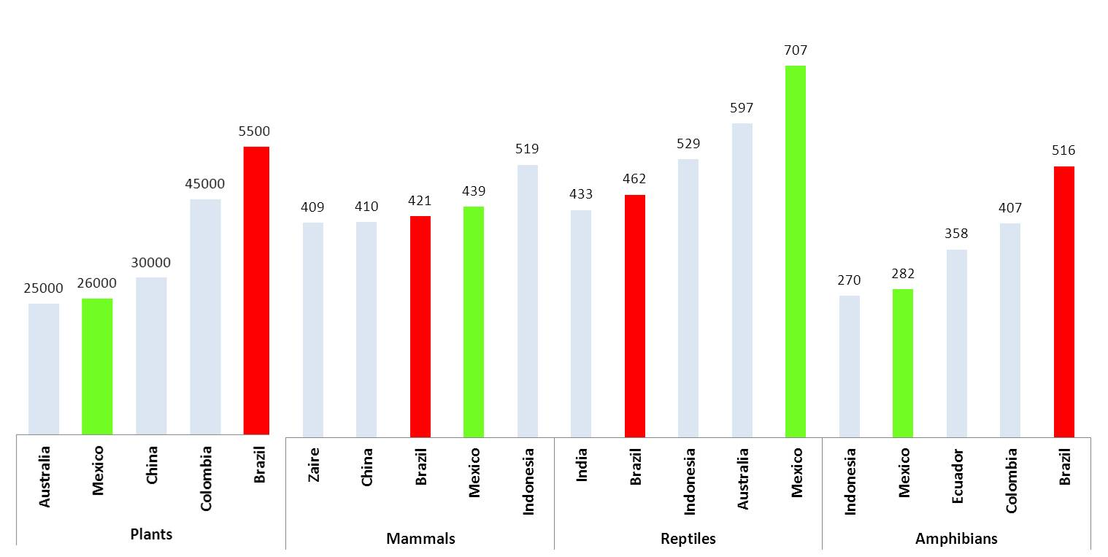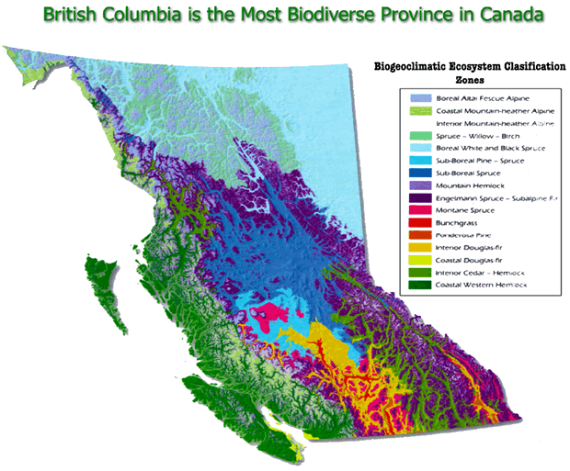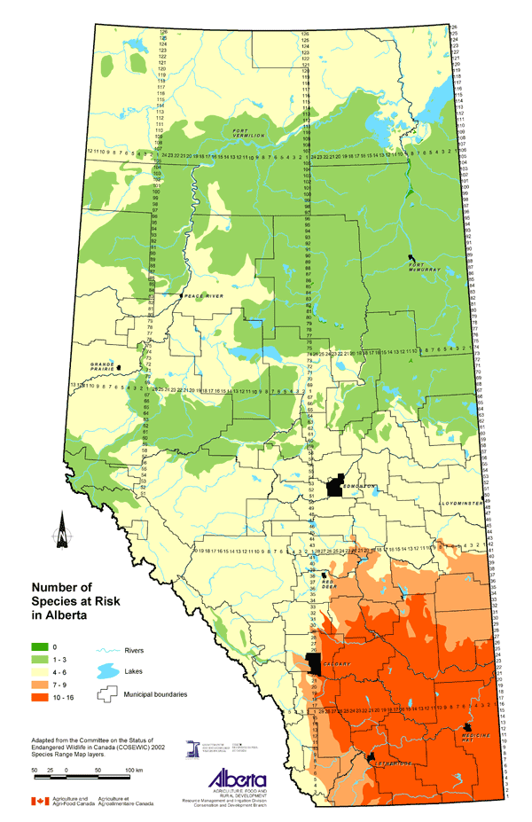
What surprised you about these 3 images?

What patterns do you see in these images?

Species: a group of organisms that 1) have similar characteristics, and 2) can breed and produce fertile offspring, ex. __________, ___________________, ____________________, ________________________.
Variation: Differences within a species (variation) or between species (biological diversity)
Why is variation/biological diversity crucial to survival? 1) All organisms have a job (niche) essential to keeping the ecosystem working so we need lots of different organisms for a healthy ecosystem, and 2) variation provides ways for a species to adapt to change in the environment
Lab: Diversity Within the Human Species: complete the lab, graph each of the data sets into bar graphs (4) on the computer, and answer the questions on the lab sheet. MAKE SURE you do the bar graphs using the 10 point marking scheme.
Speciation
Speciation: When one species adapts and changes over time and eventually evolves into several new species. 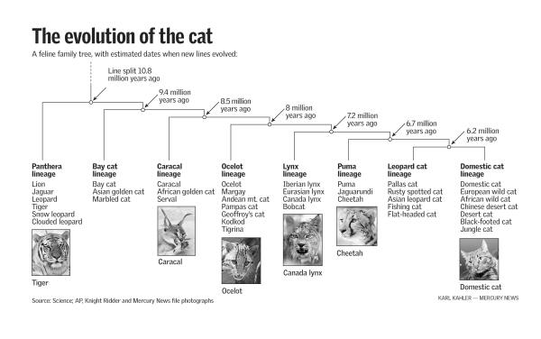 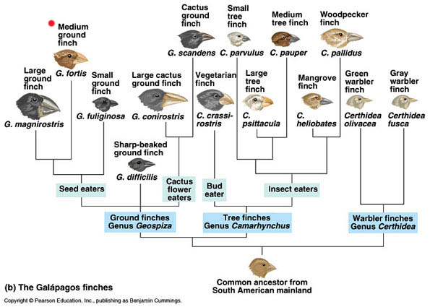
1) Many studies show that similar species such as wild cats like the lynx, bobcat, and cougar came from a common ancestor. Why did the common ancestor evolve into a variety of similar yet different species?
2) Great biological diversity often occurs on islands, or other places where animals and plants have been isolated for a long time. Why is that?
Investigation p. 11 “The Galapagos Finches”
Adaptations
Every organism has adaptations that ensure it survives. There are 2 types of adaptations:
Structural adaptation: a physical feature of an animal or plant that helps the organism to
survive in its environment.
Behavioral adaptation: an action or behavior that an organism displays that helps it survive
in its environment.
LEARNING CHECK! Fill out the following table by indicating if the adaptation listed is
structural or behavioral.
ADAPTATION | STRUCTURAL OR BEHAVIORAL
Migration of Monarch butterflies
Black skin and hollow hairs of a polar bear for warmth
Hibernation of bears in the winter
Waxy coating on a desert plant
Webbed feet of a duck for swimming

Read “The Value of Variation” p. 13. Why does a forest with many tree species (greater biological diversity) have a good chance of staying healthy even if the pine beetle attacks it? ___________________________________________________________________________________________. Why would a forest with mature and young lodgepole pine (greater variety) have a better chance of surviving a pine beetle attack? ___________________________________________________________________________________________.
Calculating Biological Diversity
Biological diversity is measured by calculating the DIVERSITY INDEX.
Read pg. 13. Do Investigation p. 14 “Using the Diversity Index” and the practice sheet “A Guide to Using the Diversity Index.” Complete vocab 1-7 and the online Sci Focus quiz for Unit 1 Topic 1. Do Topic 1 Review p. 15 #2,5,6.

