SCI 10 POTENTIAL ENERGY

What is potential energy?

What are the types of potential energy?
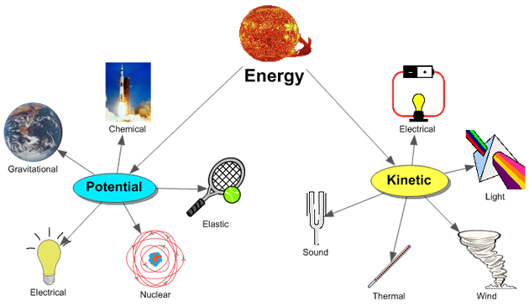
TYPE OF ENERGY | DESCRIPTION OF THE ENERGY

Gravity – is a property of all objects that have a mass. Any 2 masses will attract
to each other with a gravitational force. The forces are hardly noticeable
unless the masses are planets, moons, stars or other large bodies.

Objects that are near the Earth's surface fall with the same acceleration – this is called the acceleration due to gravity. It is represented as g = 9.81 m/s².
This means the object is falling at a speed of 9.81 m/s every second!

Examine the picture below. What types of energy are being depicted here?
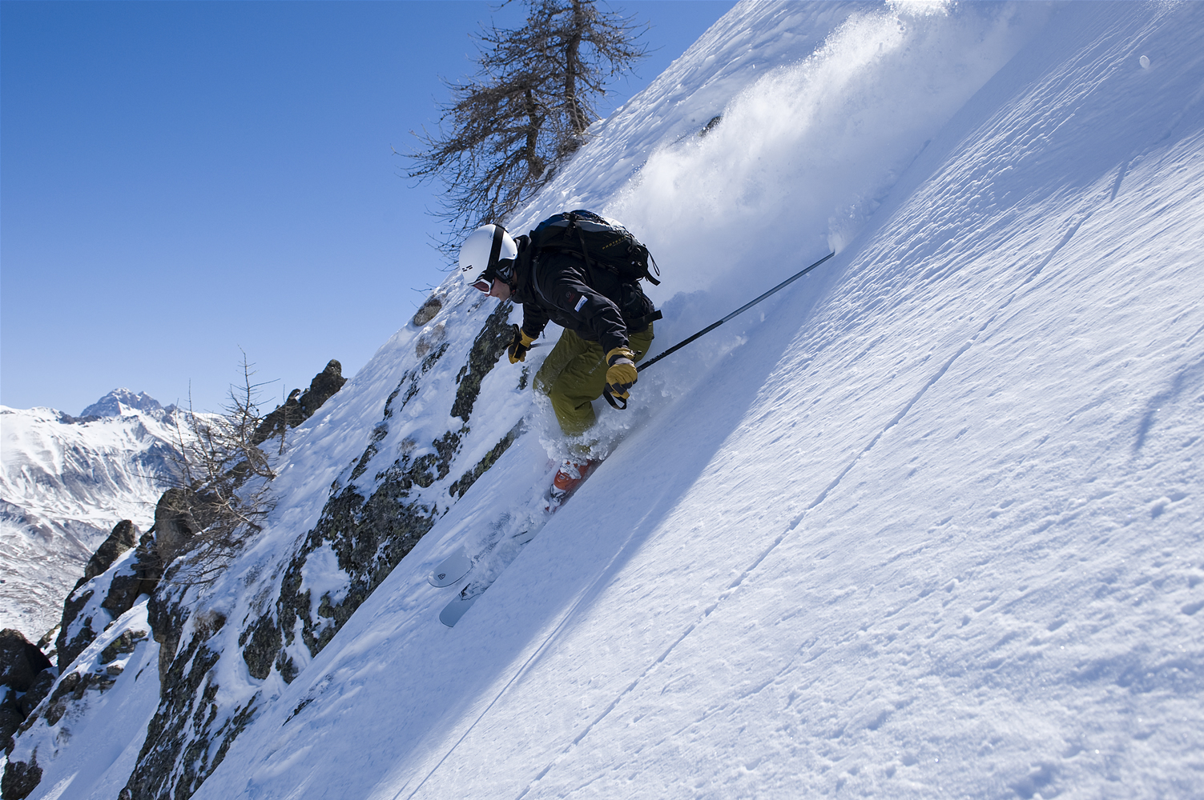

Begin with the SUN---→

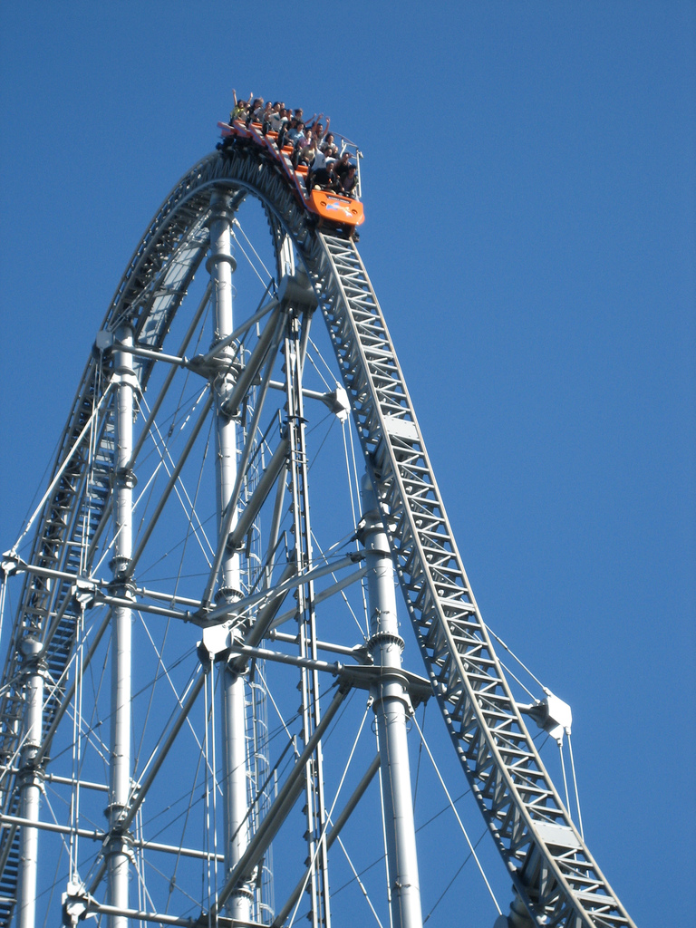

Consider the example in the picture above.
The potential energy that the roller coaster has before it goes down the track is called its gravitational potential energy. E_{g} is equal to the amount of energy (work) that was needed to get the roller coaster to the top. This energy is calculated by using the W = FΔd where W = work
F = force (N) (F = mg) m = mass and g = acceleration due to gravity)
Δd = change in distance (m)

If W = FΔd, and F = mg, then W = mgΔd.
Since we're usually dealing with objects that are elevated (ie on a table, etc), the
Δd can be substituted with Δh, which makes the formula:

W = E_{g} = mgΔh

or E_{g} = mgΔh

E_{g} = measured in Joules (J)
m = measured in kg
g = measured in m/s²
Δh = measured in m

The roller coaster in the above picture moves its passengers a vertical distance of 42.1 m above the ground. If the total mass of the roller coaster and passengers is 5.27 X 10³ kg, what is the gravitational potential energy of the roller coaster and passengers relative to the ground? How much work did the engine do on the roller coaster and passengers in carrying them to the top?

GRAVITATIONAL POTENTIAL ENERGY PROBLEMS

1. The shelf in your school locker is 1.8 m above the floor. If your science book
has a mass of 1200 g, what is the gravitational potential energy relative to
floor if it is sitting on the shelf?

2. A student used 85 N of force to raise a box up to a shelf that was 0.75 m
above the ground. What was the mass of the box? (Hint: W = E_{g})

3. A 27 kg child sits at the top of a playground slide that is 2.8 m above the ground. What is the child’s gravitational potential energy relative to the ground?

4. How far would you have to lift a 1.2 kg book to give it 40.0 J of gravitational potential energy?

5. A chair lift did 5.60 X 10⁵ J of work on a 64 kg skier to carry the skier to the top of the mountain. How high is the top of the mountain relative to the base of the lift?

6. How high would you have to throw a 0.300 kg baseball so that it would have 120.0 J of gravitational potential energy at its highest point relative to the ground?

7. You did 583 J of work on a box of books while carrying it a vertical distance of 3.3 m up a flight of stairs. What was the mass of the box of books?

8. While a child is swinging on a playground swing, she reaches a height of 2.8 m above the ground. If she had 604 J of gravitational potential energy relative to the ground at the highest point, what is her mass?

9. A boulder rests on a ledge 36 m above a lake. If it has 2.8 X 10⁵ J of gravitational potential energy relative to the lake surface, what is the mass of the boulder?

